26.14 Editors - Properties Editor - Material Properties Tab
Detailed table of content 2
Preface 7
Affected Renderer 7
Material header 7
Material List 8
Add Material Slot 8
Remove Material Slot 8
Materials Specials menu 9
Material data property 10
Edit Mode 10
Preview Panel 11
Flat, Sphere, Cube, etc. 11
Preview World 11
Surface Panel 11
Use Nodes 11
Surface Panel - Grease Pencil Object 12
Presets 12
Stroke Subpanel 12
Fill Subpanel 15
Volume Panel 17
Use Nodes 18
Displacement Panel 18
Use Nodes 18
Settings Panel - Eevee renderer 18
Backface Culling 18
Blend Mode 18
Shadow Mode 19
Show Backface 19
Screen Space Refraction 19
Subsurface Translucency 20
Settings Panel - Cycles renderer 20
Pass Index 20
Surface 20
Volume 20
Homogeneous 20
Step rate 21
Material Library VX 21
Library Browser 21
New Library 21
Preview Window 22
Apply 22
Preview 22
Materials List 22
Add to Library 22
Reload Material 22
Remove Preview 22
Remove Material 22
Settings 22
Search 22
Category Tools: 23
Viewport Display 23
Settings 23
Backface Culling 23
Blend Mode 23
Shadow Mode 24
Show Backface 24
Screen Space Refraction 24
Subsurface Translucency 25

Detailed table of content

Detailed table of content
Detailed table of content 2
Preface 7
Affected Renderer 7
Material header 7
Material List 8
Show in ghosts 8
Hide 8
Locked 8
Drag Handler 8
Search Field 8
Sort by Name 8
Reverse 8
Add Material Slot 8
Remove Material Slot 8
Materials Specials menu 9
With a mesh or curve or other object type 9
Copy Material 9
Copy Material to selected 9
Paste Material 9
Remove Unused Slots 9
With a grease pencil stroke object 9
Show All 9
Hide Others 9
Lock All 9
Unlock All 9
Lock Unused 9
Remove Unused Slots 9
Merge Similar 9
Convert Materials to Vertex Colors 9
Extract Palette from Vertex Color 10
Material data property 10
Material Browser 10
New 10
Name 10
Fake User 10
New 10
Remove 10
Link 10
Edit Mode 10
Workflow 10
Assign 10
Select 11
Deselect 11
Preview Panel 11
Flat, Sphere, Cube, etc. 11
Preview World 11
Surface Panel 11
Use Nodes 11
Use Nodes unticked with Eevee 11
Use Nodes unticked with Cycles 11
Use Nodes ticked 11
Surface Panel - Grease Pencil Object 12
Presets 12
Stroke Subpanel 12
Mode Type 12
Mode Type Line 13
Style 13
Solid 13
Base Color 13
Texture 13
Base Color 13
Image Prop 13
Image browser 13
Search form 13
Image Edit Box 13
Number of Fake Users 13
Fake User 13
Open 13
Remove 13
Self Overlap 14
Holdout 14
Mode Type Dots + Squares 14
Style 14
Solid 14
Base Color 14
Texture 14
Base Color 14
Image Prop 14
Image browser 14
Search form 14
Image Edit Box 14
Number of Fake Users 14
Fake User 14
Open 15
Remove 15
Alignment 15
Path 15
Object 15
Fixed 15
Self Overlap 15
Rotation 15
Holdout 15
Fill Subpanel 15
Style 15
Solid 15
Base Color 15
Holdout 15
Gradient 16
Gradient Type 16
Base Color 16
Secondary Color 16
Blend 16
Flip Colors 16
Location X / Y 16
Rotation 16
Scale X / Y 16
Holdout 16
Texture 16
Base Color 16
Image Prop 16
Image browser 17
Search form 17
Image Edit Box 17
Number of Fake Users 17
Fake User 17
Open 17
Remove 17
Location X / Y 17
Rotation 17
Scale X / Y 17
Clip Image 17
Holdout 17
Volume Panel 17
Use Nodes 18
Displacement Panel 18
Use Nodes 18
Settings Panel - Eevee renderer 18
Backface Culling 18
Blend Mode 18
Opaque 18
Alpha Clip 19
Clip threshold 19
Alpha Hashed 19
Alpha Blend 19
Shadow Mode 19
None 19
Opaque 19
Alpha Clip 19
Clip threshold 19
Alpha Hashed 19
Show Backface 19
Screen Space Refraction 19
Refraction depth 19
Subsurface Translucency 20
Pass Index 20
Settings Panel - Cycles renderer 20
Pass Index 20
Surface 20
Multiple Importance 20
Transparent Shadows 20
Displacement 20
Volume 20
Sampling 20
Interpolation 20
Homogeneous 20
Step rate 21
Material Library VX 21
Library Browser 21
New Library 21
Preview Window 22
Apply 22
Preview 22
Materials List 22
Add to Library 22
Reload Material 22
Remove Preview 22
Remove Material 22
Settings 22
Force Import 22
Linked 22
Hide Search 22
Search 22
Category Tools: 23
Filter 23
Set Type 23
Add 23
Remove 23
Viewport Display 23
Settings 23
Backface Culling 23
Blend Mode 23
Opaque 24
Alpha Clip 24
Clip threshold 24
Alpha Hashed 24
Alpha Blend 24
Shadow Mode 24
None 24
Opaque 24
Alpha Clip 24
Clip threshold 24
Alpha Hashed 24
Show Backface 24
Screen Space Refraction 24
Refraction depth 25
Subsurface Translucency 25
Pass Index 25

Preface
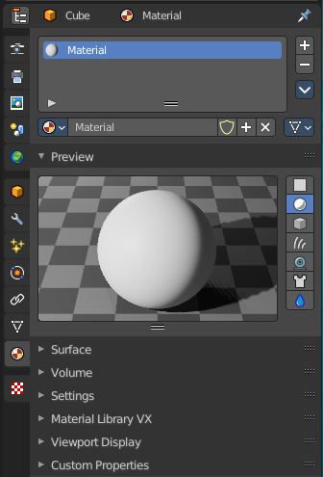
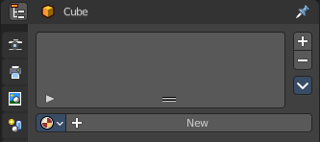
Materials controls the appearance of meshes, curves, volumes and other objects.

A material is the container that contains all the necessary data to define the look of an object. I is made of a code part, the shaders. They control how the surface reacts. And color data like textures. A black and white texture can also control what areas of a shader reacts in what way. Like a gloss map.

Materials can be created in either the Material properties, or in the Shader Editor. The content that is displayed is the same. But the way how it is represented is different.

Materials can be assigned to one or more objects, and different materials can be assigned to different parts of meshes.

The material system is built with physically-based rendering in mind. But can also be used to create toon style materials.

Affected Renderer
The material system is for Eeevee and Cycles. Workbench renderer is meant for fast preview display. It does not use materials like Eevee or Cycles. All you can choose is a color.
Eevee and Cycles have nearly the same nodes available. But some nodes differs. Eevee is a realtime renderer. Cycles is a physically based render. That's two different approaches. So you should take that into account when creating the materials.

Material header

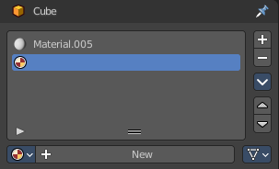
The header area contains the list of materials and the functionality to create new materials and to remove them.

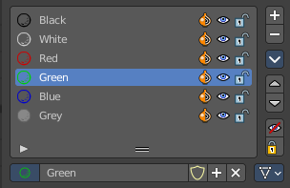
Note that a material for a grease pencil object differs from the rest. It is basically the same. But grease pencil objects have other icons in the material browser.

Material List
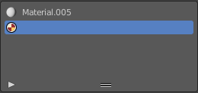
The list of assigned materials to this object. The list shows the material slots. A material slot that has the red material icon assigned has no material content yet. It is just an empty slot. You have to create it first by clicking at the New button below, in the material property.
Clicking at the name allows renaming of the material.
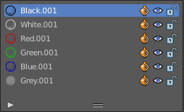
Grease pencil materials have additional functionality in the list.

Show in ghosts
Turn on onion skinning for this material. Onion skinning displays strokes before and after the current frame.

Hide
Show or hide the material.

Locked
Protect color from further editing.

Drag Handler
The two vertical lines at the end is a handler with which you can expand the list.

Search Field

You can expand a search field at the bottom of the list. Type in your term and hit enter to filter for your term.

Sort by Name
Sort the List by name.

Reverse
Exclude the search term instead of searching for it.

Add Material Slot
Add a new material slot

Remove Material Slot
Remove the selected material slot.

Materials Specials menu

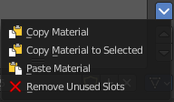
With a mesh or curve or other object type

Copy Material
Copy the material settings and nodes.

Copy Material to selected
Copy material to selected objects. First select the object without material. Hold down shift and select the object with material. Perform Copy material to selected.

Paste Material
Pastes a copied material.

Remove Unused Slots
Remove material slots that does not contain a material.

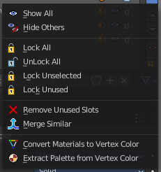
With a grease pencil stroke object

Show All
Show all materials.

Hide Others
Hide unselected materials.

Lock All
Lock all materials from editing.

Unlock All
Unlock all materials.

Lock Unused
Lock unused materials from editing.

Remove Unused Slots
Remove material slots that does not contain a material.

Merge Similar
Merge similar materials in stroke.

Convert Materials to Vertex Colors
Grease pencil strokes can have either vertex colors or material colors. This feature converts the selected materials to a vertex color palette.

Extract Palette from Vertex Color
Grease pencil strokes can have either vertex colors or material colors. This feature converts a vertex color palette to materials.

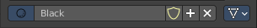
Material data property

Material Browser
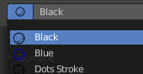
A list of the available materials in the scene where you can choose a material from.

New
When the object has no material yet. Creates a new default material and adds a first material slot to the list.

Name
The name of the active material. Double clicking allows to rename it.

Fake User
Keep this data even when it has no user in the scene.

New
Creates a new default material, and assigns it to the active material slot.

Remove

Link
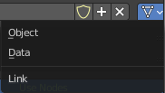
Specifies whether the material is to be linked to the Object or to the Object Data.
Different objects may share the same mesh data. And if the material is linked to the mesh, every object will share it. If the material is linked directly to the object data, the objects can have different materials and still share the same mesh. Default is Data.

Edit Mode
In Edit mode you can assign different materials at different mesh or curve parts.

Workflow
Enter Edit Mode. Select the material that you want to assign. Select the mesh or curve part. Click at the assign button.

Assign
Assign active material slot and material to the selected faces in the mesh, strokes in a Grease Pencil, and similar for other object types.

Select
Select faces assigned to the active material slot.

Deselect
Deselect faces assigned to the active material slot.

Preview Panel

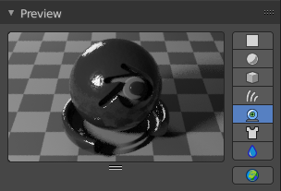
A preview window to judge the material.

Flat, Sphere, Cube, etc.
Different shaped preview objects.

Preview World
Include the world settings into the preview rendering.

Surface Panel

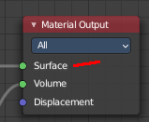
This panel displays the Surface part of the material as a list. And allows you to edit its values.

Use Nodes
Choose if you want to use nodes or not. Unticked it will use a default material with just basic values. Ticked it will use the material as defined in the shader editor in the Shading workspace. And display its values.
The values with unticked Use Nodes will not appear in the material node editor.

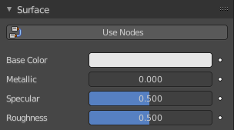
Use Nodes unticked with Eevee
Gives you the values for a very basic PBR realtime shader.

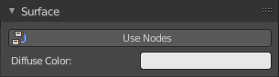
Use Nodes unticked with Cycles
Gives you a base color.

Use Nodes ticked
Displays the content of the material in the shader editor as a list.
Triangle buttons indicates that there is a node connected to this input. You can expand this triangle to access the values of the connected node.
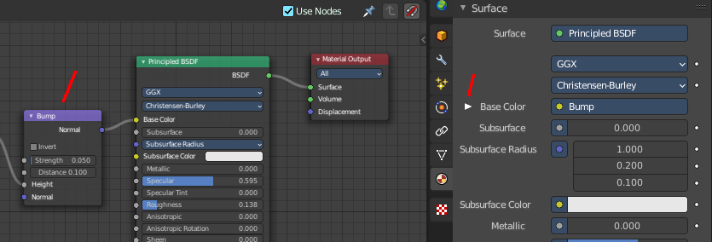

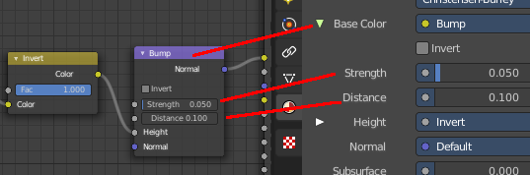

For the nodes and the values please have a look in the shader editor.

Surface Panel - Grease Pencil Object
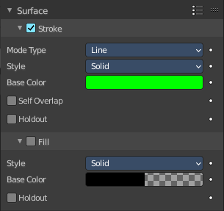
The content of the surface panel with a grease pencil object is a bit different from other object types since Grease pencil objects uses materials for the drawing color.

Presets
The presets in the header allows you to use and store presets.

Stroke Subpanel
Stroke related settings.

Mode Type
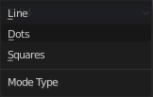
The draw mode for the stroke. The modes should be self explaining. Most settings are the same in all modes.

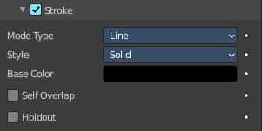
Mode Type Line

Style
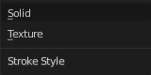
The draw style.

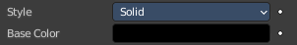
Solid

Base Color
The color of the stroke.

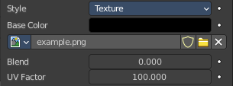
Texture

Base Color
The base color of the stroke. You can blend the texture with this color.

Image Prop
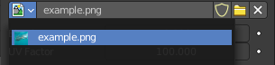
This property contains the list of loaded images. When no image is loaded then it displays the Open Buttons. When an image exists then it displays the name of the currently selected image.

From left to right ...

Image browser
This is a list of the images in the scene. This list allows you to switch to other images.

Search form
Search for specific images.

Image Edit Box
Read the name of the currently selected image. And you can rename the image here too.

Number of Fake Users
In case this file has a fake user assigned, then this number displays the number of fake users.

Fake User
Wit this button you assign a fake user to this selected image.
Data, like images, that is not longer linked to anything else gets removed when you save and reload a scene. Bforartists has the concept of fake users to go around this behavior. An image with a fake user is in fact linked to something. And so it is not lost when you save and reload the scene.

Open
Open a new image.

Remove
Removes the image.

Self Overlap
Disable stencil and allow self intersections with alpha materials.

Holdout
Remove the color from underneath this stroke by using the stroke as a mask.

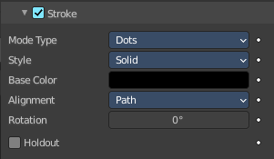
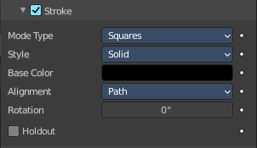
Mode Type Dots + Squares

Style
The draw style.

Solid

Base Color
The color of the stroke.

Texture

Base Color
The base color of the stroke. You can blend the texture with this color.

Image Prop
This property contains the list of loaded images. When no image is loaded then it displays the Open Buttons. When an image exists then it displays the name of the currently selected image.

From left to right ...

Image browser
This is a list of the images in the scene. This list allows you to switch to other images.

Search form
Search for specific images.

Image Edit Box
Read the name of the currently selected image. And you can rename the image here too.

Number of Fake Users
In case this file has a fake user assigned, then this number displays the number of fake users.

Fake User
Wit this button you assign a fake user to this selected image.
Data, like images, that is not longer linked to anything else gets removed when you save and reload a scene. Bforartists has the concept of fake users to go around this behavior. An image with a fake user is in fact linked to something. And so it is not lost when you save and reload the scene.

Open
Open a new image.

Remove
Removes the image.

Alignment
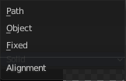
Dots and Squares mode.

Path
Alignment follows stroke drawing path and object rotation.

Object
Alignment follows object rotation only.

Fixed
Keeps aligned with viewport.

Self Overlap
Disable stencil and allow self intersections with alpha materials.

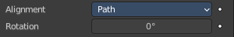
Rotation
Additional rotation applied to dot and square strokes.

Holdout
Remove the color from underneath this stroke by using the stroke as a mask.

Fill Subpanel
Fill color related settings.

Style

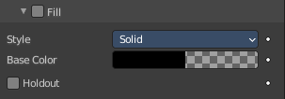
Solid

Base Color
The color of the stroke.

Holdout
Remove the color from underneath this stroke by using the stroke as a mask.

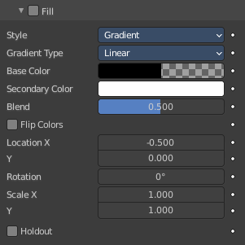
Gradient

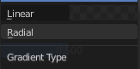
Gradient Type
Draw a linear or a radial gradient.

Base Color
The first color of the gradient.

Secondary Color
The second color of the gradient.

Blend
The mix factor between the first and second gradient color.

Flip Colors
Flip the filling colors.

Location X / Y
The location of the gradient.

Rotation
The rotation of the gradient.

Scale X / Y
The scale of the gradient.

Holdout
Remove the color from underneath this stroke by using the stroke as a mask.

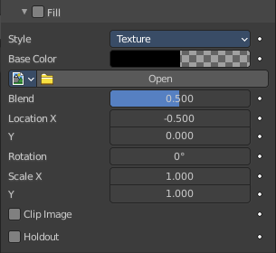
Texture

Base Color
The base color of the stroke. You can blend the texture with this color.

Image Prop
This property contains the list of loaded images. When no image is loaded then it displays the Open Buttons. When an image exists then it displays the name of the currently selected image.

From left to right ...

Image browser
This is a list of the images in the scene. This list allows you to switch to other images.

Search form
Search for specific images.

Image Edit Box
Read the name of the currently selected image. And you can rename the image here too.

Number of Fake Users
In case this file has a fake user assigned, then this number displays the number of fake users.

Fake User
Wit this button you assign a fake user to this selected image.
Data, like images, that is not longer linked to anything else gets removed when you save and reload a scene. Bforartists has the concept of fake users to go around this behavior. An image with a fake user is in fact linked to something. And so it is not lost when you save and reload the scene.

Open
Open a new image.

Remove
Removes the image.

Location X / Y
The location of the image.

Rotation
The rotation of the image.

Scale X / Y
The scale of the image.

Clip Image
Do not repeat the image, but clamp it to one instance.

Holdout
Remove the color from underneath this stroke by using the stroke as a mask.

Volume Panel

This panel displays the Volume part of the material as a list. And allows you to edit its values.

Use Nodes
Choose if you want to use a volume node or not.
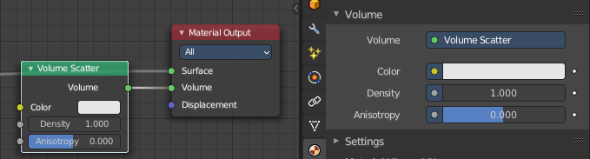

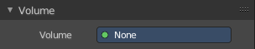
Removing the volume node in the shader editor will clear the volume panel.

Displacement Panel

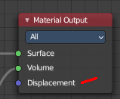
This panel displays the Displacement part of the material as a list. And allows you to edit its values.

Use Nodes
Choose if you want to use a displacement node or not.
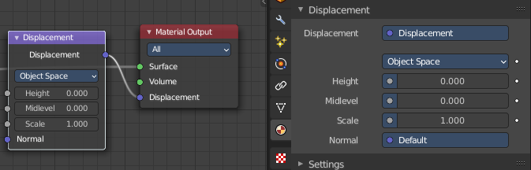

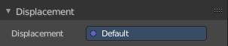
Removing the displacement node in the shader editor will clear the panel.

Settings Panel - Eevee renderer
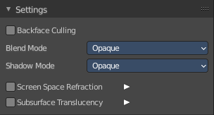

Backface Culling
Use back face culling to hide the back side of faces.

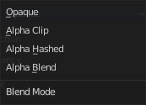
Blend Mode
The blend mode for transparent faces.

Opaque
Render surface without transparency.

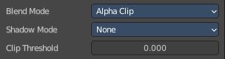
Alpha Clip
Use the alpha threshold to clip the visibility. On or off.

Clip threshold
A pixel is just rendered if the value is higher than this clip threshold. This threshold is the same for blend mode and shadow mode.

Alpha Hashed
Use Noise to dither the binary visibility. Works best with multi samples.

Alpha Blend
Render polygons transparent, dependent of the alpha channel of the texture.

Shadow Mode

None
Material will cast no shadow.

Opaque
Material will cast shadow without transparency.

Alpha Clip
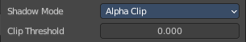
Use the alpha threshold to clip the visibility. On or off.

Clip threshold
A pixel is just rendered if the value is higher than this clip threshold. This threshold is the same for blend mode and shadow mode.

Alpha Hashed
Use Noise to dither the binary visibility.

Show Backface
With Blend Mode Alpha Blend. Limit the transparency to a single layer to avoid transparency layer sort problems.

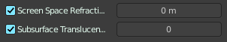
Screen Space Refraction
Use ray traced screen space refraction.

Refraction depth
The thickness of the object to compute two refraction event. 0 means disabled.

Subsurface Translucency
Add translucency effect to subsurface.

Pass Index
Index number for the material index render pass.

Settings Panel - Cycles renderer

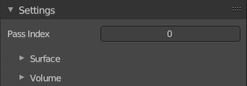
Material settings.

Pass Index
The index number of this material. This material index can be used for masking in post processing for example.

Surface
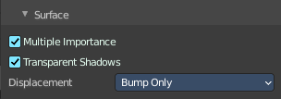
Surface related settings.

Multiple Importance
By default lights use only direct light sampling. Which can be noisy with sharp glossy reflections. Multiple Importance activates Indirect light sampling to reduce noise.

Transparent Shadows
Use transparent shadows if the material contains a transparent bsdf node.

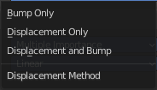
Displacement
What method to use for displacement.

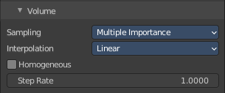
Volume

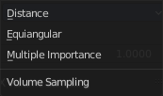
Sampling
What sampling method to use for volume rendering.

Interpolation
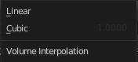
What interpolation method to use for volume rendering.

Homogeneous
Assume to have a homogeneous volume to speed up rendering.

Step rate
Scale the distance between volume shader samples when rendering the volume. Lower values increases accuracy and render time.
Step rate becomes dysfunctional when Homogeneous is activated.

Material Library VX

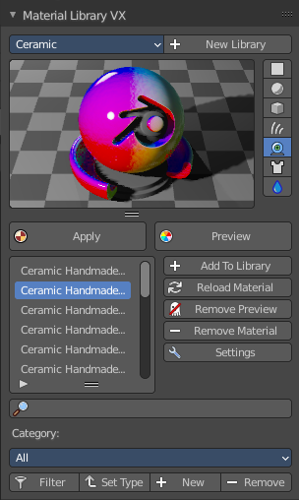
Materials Library VX is a Blender material library add-on. You can save, load and categorize materials that can be shared across all your projects.

It’s advisable to add a Fake User to your materials and to save your blend-file before use.

Note that this add-on creates a material_preview_dummy object to allow the material preview.
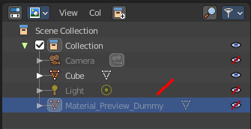

Library Browser
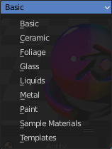
A list of the available libraries. Switching to another library will load it.

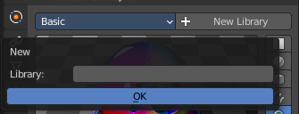
New Library
Create a new Library and name it. The new library will have one material to start.

Preview Window
A material preview window.

Apply
Apply the currently selected material to the object. Note, sometimes the object gets deselected. And then you get a warning. Simply select the object, and try again.

Preview
The material can be previewed before you assign it. Preview will also refresh the material preview window. It is not updated by choosing another material.

Materials List
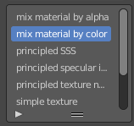
The list of the available materials in this library. Choose a material, click at the Preview button to preview it in the preview window. Click at the Apply button to assign the material to the selected object.

Add to Library
Add your materials to the library.

Reload Material
Restore the saved version of the material if you want to revert edits.

Remove Preview
Restore the Preview panel.

Remove Material
Delete the active material from the Matlib VX list and your library.

Settings
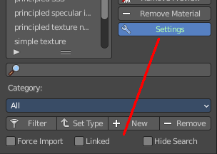
Options. They appear at the end.

Force Import
Use Scene Materials by default.

Linked
Link the material instead of append it.

Hide Search
Hides the search field.

Search
Search the library for a material.

Category Tools:
Here you can make sub categories.

Note, this part is simply broken. Don't even bother.

Filter
Apply the current filter.

Set Type
Apply the current selected category to the current material library.

Add
Add a new category.

Remove
Remove the current selected category from the list.

Viewport Display

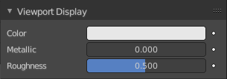
Display settings for viewport display mode Solid. The items should be self explaining.

Settings
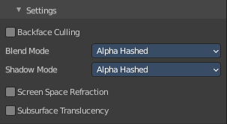
Cycles only. And with Cycles these settings are just relevant for the viewport rendering in Material Preview mode. That's why they are in the viewport display panel.
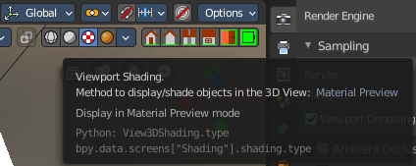

Backface Culling
Use back face culling to hide the back side of faces.

Blend Mode
The blend mode for transparent faces.

Opaque
Render surface without transparency.

Alpha Clip
Use the alpha threshold to clip the visibility. On or off.

Clip threshold
A pixel is just rendered if the value is higher than this clip threshold. This threshold is the same for blend mode and shadow mode.

Alpha Hashed
Use Noise to dither the binary visibility. Works best with multi samples.

Alpha Blend
Render polygons transparent, dependent of the alpha channel of the texture.

Shadow Mode

None
Material will cast no shadow.

Opaque
Material will cast shadow without transparency.

Alpha Clip
Use the alpha threshold to clip the visibility. On or off.

Clip threshold
A pixel is just rendered if the value is higher than this clip threshold. This threshold is the same for blend mode and shadow mode.

Alpha Hashed
Use Noise to dither the binary visibility.

Show Backface
With Blend Mode Alpha Blend. Limit the transparency to a single layer to avoid transparency layer sort problems.

Screen Space Refraction
Use ray traced screen space refraction.

Refraction depth
The thickness of the object to compute two refraction event. 0 means disabled.

Subsurface Translucency
Add translucency effect to subsurface.

Pass Index
Index number for the material index render pass.

